HOSPITAL MANAGEMENT SYSTEM

CREATE DATABASE hospital_management;
USE hospital_management;
Department
CREATE TABLE Department(
departmentid INT PRIMARY KEY AUTO_INCREMENT,
departmentname VARCHAR(100)
);
Patient
CREATE TABLE Patient(
patientid INT PRIMARY KEY AUTO_INCREMENT,
name VARCHAR(100),
age INT,
gender VARCHAR(10),
phone VARCHAR(15),
address VARCHAR(200)
);
Doctor
CREATE TABLE Doctor(
doctorid INT PRIMARY KEY AUTO_INCREMENT,
name VARCHAR(100),
specialization VARCHAR(100),
departmentid INT,
phone VARCHAR(15),
FOREIGN KEY(departmentid)
REFERENCES Department(departmentid)
);
Appointment
CREATE TABLE Appointment(
appointmentid INT PRIMARY KEY AUTO_INCREMENT,
patientid INT,
doctorid INT,
appointmentdate DATE,
status VARCHAR(50),
FOREIGN KEY(patientid)
REFERENCES Patient(patientid),
FOREIGN KEY(doctorid)
REFERENCES Doctor(doctorid)
);
Treatment
CREATE TABLE Treatment(
treatmentid INT PRIMARY KEY AUTO_INCREMENT,
patientid INT,
doctorid INT,
description VARCHAR(255),
treatmentdate DATE,
FOREIGN KEY(patientid)
REFERENCES Patient(patientid),
FOREIGN KEY(doctorid)
REFERENCES Doctor(doctorid)
);
Bill
CREATE TABLE Bill(
billid INT PRIMARY KEY AUTO_INCREMENT,
patientid INT,
amount DECIMAL(10,2),
billdate DATE,
payment_status VARCHAR(20),
FOREIGN KEY(patientid)
REFERENCES Patient(patientid)
);
Department
INSERT INTO Department(departmentname)
VALUES
('Cardiology'),
('Neurology'),
('Orthopedics');
Doctor
INSERT INTO Doctor
(name,specialization,departmentid,phone)
VALUES
('Ravi Kumar','Cardiologist',1,'9876543210'),
('Anita Sharma','Neurologist',2,'9876543211'),
('Rahul Singh','Orthopedic',3,'9876543212');
Patient
INSERT INTO Patient
(name,age,gender,phone,address)
VALUES
('Amit',25,'Male','9999999991','Bangalore'),
('Priya',30,'Female','9999999992','Mysore'),
('Karan',40,'Male','9999999993','Mangalore');
Appointment
INSERT INTO Appointment
(patientid,doctorid,appointmentdate,status)
VALUES
(1,1,'2026-06-10','Completed'),
(2,2,'2026-06-12','Pending'),
(3,3,'2026-06-15','Scheduled');
Treatment
INSERT INTO Treatment
(patientid,doctorid,description,treatmentdate)
VALUES
(1,1,'Heart Checkup','2026-06-10'),
(2,2,'Brain Scan','2026-06-12');
Bill
INSERT INTO Bill
(patientid,amount,billdate,payment_status)
VALUES
(1,5000,'2026-06-10','Paid'),
(2,7000,'2026-06-12','Pending');
View Patients
SELECT * FROM Patient;
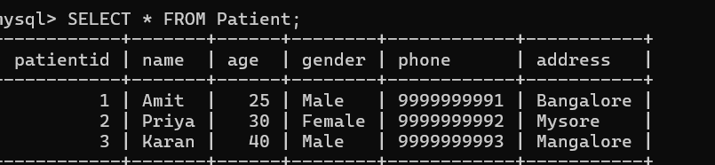

View Doctors
SELECT * FROM Doctor;
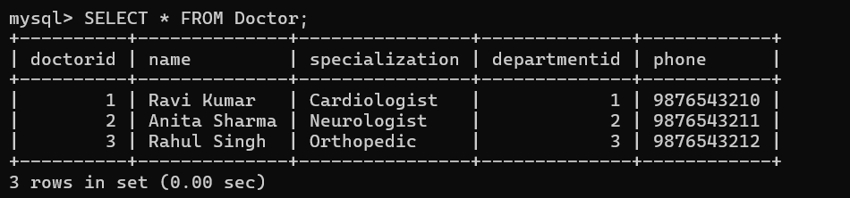

View Appointments
SELECT * FROM Appointment;
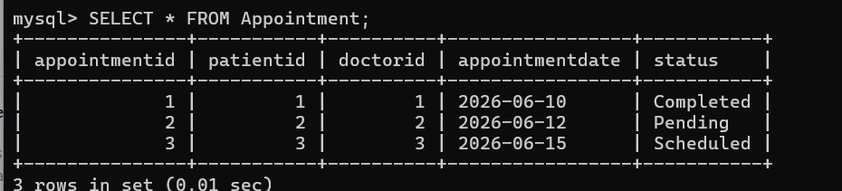

Patient + Doctor Details
SELECT
P.name AS Patient,
D.name AS Doctor,
A.appointmentdate
FROM Appointment A
JOIN Patient P
ON A.patientid=P.patientid
JOIN Doctor D
ON A.doctorid=D.doctorid;
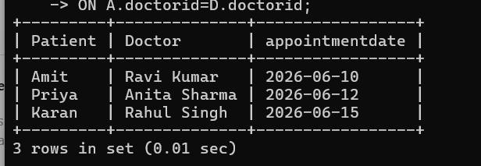

Bills
SELECT * FROM Bill;
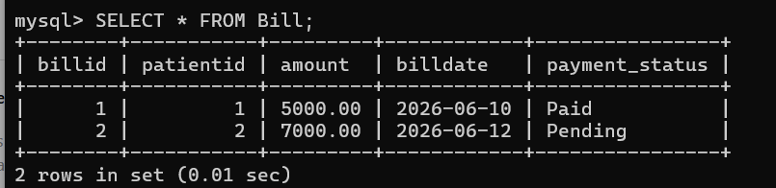

Pending Bills
SELECT *
FROM Bill
WHERE payment_status='Pending';
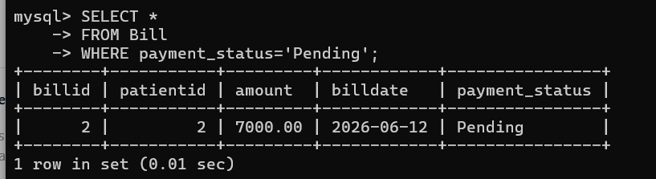

Count Patients
SELECT COUNT(*) AS TotalPatients
FROM Patient;
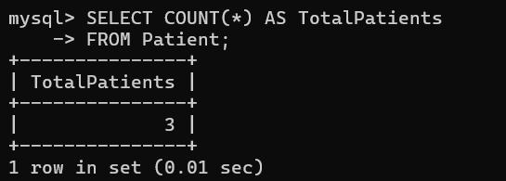

Total Revenue
SELECT SUM(amount) AS Revenue
FROM Bill;
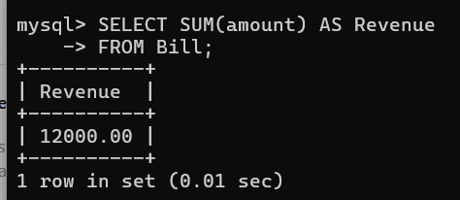

Update Query
UPDATE Bill
SET payment_status='Paid'
WHERE billid=2;
Delete Query
DELETE FROM Appointment
WHERE appointmentid=3;
View Structure
DESC Patient;
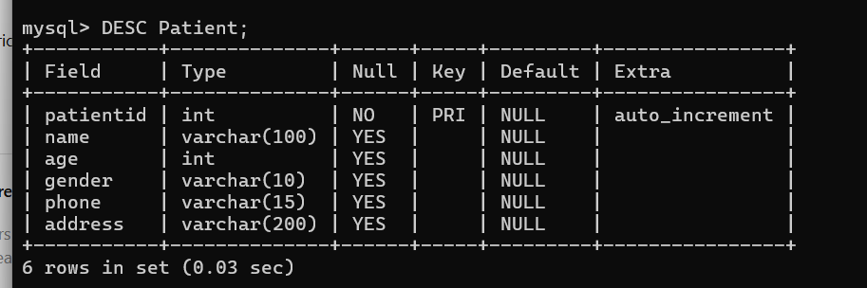

Create View
CREATE VIEW PatientBills AS
SELECT
P.name,
B.amount,
B.payment_status
FROM Patient P
JOIN Bill B
ON P.patientid=B.patientid;
Use:
SELECT * FROM PatientBills;
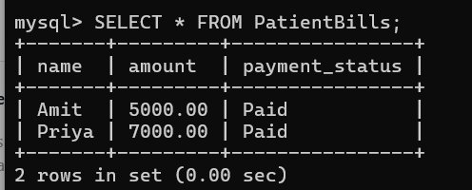

Stored Procedure
DELIMITER //
CREATE PROCEDURE GetPatientDetails()
BEGIN
SELECT * FROM Patient;
END //
DELIMITER ;
Execute:
CALL GetPatientDetails();
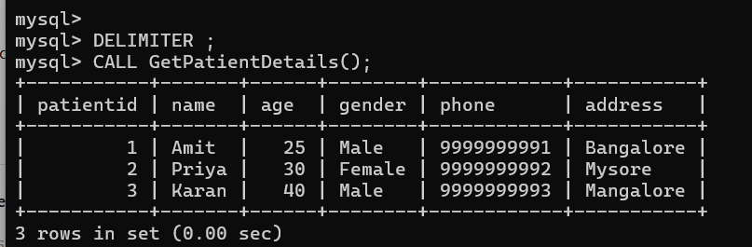

Trigger
Create log table:
CREATE TABLE Bill_Log(
logid INT AUTO_INCREMENT PRIMARY KEY,
patientid INT,
amount DECIMAL(10,2),
actiontime TIMESTAMP DEFAULT CURRENT_TIMESTAMP
);

Trigger:
DELIMITER //
CREATE TRIGGER bill_insert_trigger
AFTER INSERT ON Bill
FOR EACH ROW
BEGIN
INSERT INTO Bill_Log(patientid,amount)
VALUES(NEW.patientid,NEW.amount);
END //
DELIMITER ;
Test:
INSERT INTO Bill
(patientid,amount,billdate,payment_status)
VALUES
(3,8000,CURDATE(),'Paid');

